MASK WEAR DETECTION

***Wireframe Documentation***

Homepage

We have divided MASK WEAR DETECTION 2 PARTS -

1. First thing anyone will set the person didn’t wear the mask .

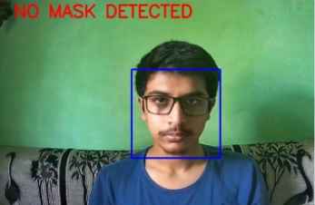

1. In Second image show person wear the mask

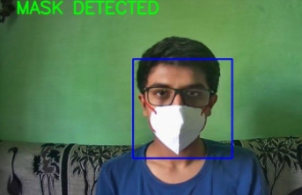

Based on User’s code will detect person wear mask or not via this model

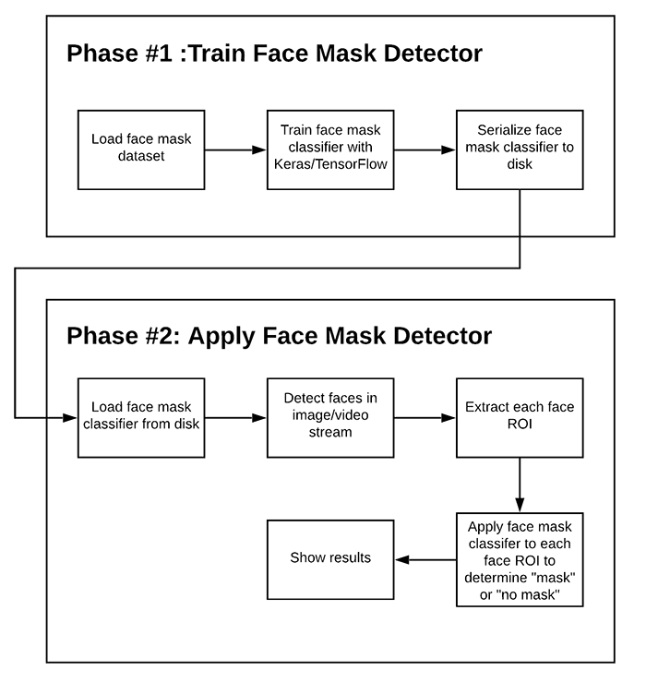

# Final Output

In this Page, we will showcase

